MINISTRY OF EDUCATION AND SCIENCE OF UKRAINE

NATIONAL TECHNICAL UNIVERSITY

«KHARKIV POLYTECHNIC INSTITUTE»

Department of Software Engineering and Management Information Technologies

Report from lab № 8

discipline «Algorithm and Data Structures»

Executed by:

Student of group KN.201.8g2

BARKANE OUSSAMA

Checked by:

Associate professor

M.O Belova

Kharkiv

2019

Theme: MATHEMATICAL FOUNDATIONS OF ALGORITHM ANALYSIS (2 PAIRS)

Objective: learn how to identify the complexity of algorithms

Theory: Analyzing the algorithm, we can try to find the exact number of performed operations. But in most cases it is enough to estimate the asymptotic growth time of the algorithm when its input size tends to infinity.

Θ( g (n))={ f (n):∃ positive constants c1 , c2, and n0 so that 0≤c1 g (n)≤ f (n)≤c2 g (n)∀ n≥n0 }

1) Θ (1): Time complexity of a function (or set of statements) is considered as Θ (1) if it doesn’t contain loop, recursion and call to any other non-constant time function.

2) Θ (n): Time Complexity of a loop is considered as Θ (n) if the loop variables is incremented / decremented by a constant amount.

3) Θ (n in power c): Time complexity of nested loops is equal to the number of times the innermost statement is executed.

Task : Determine complexity for each of the implemented algorithm from previous works. To do this, specify the number of execution times for each line of the algorithm, depending on input data dimension. Write result using Θ . For algorithms from works "Basic data structures" and "Fundamental algorithms on graphs and trees", determine whether the chosen data structure is optimal, and if not, then recommend those that increase the algorithm speed.

Main part:

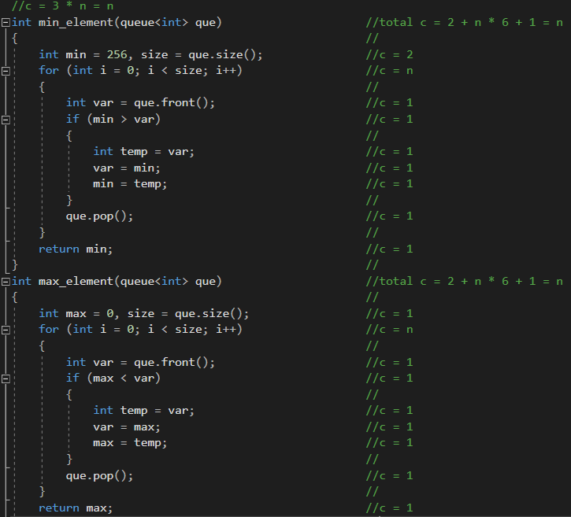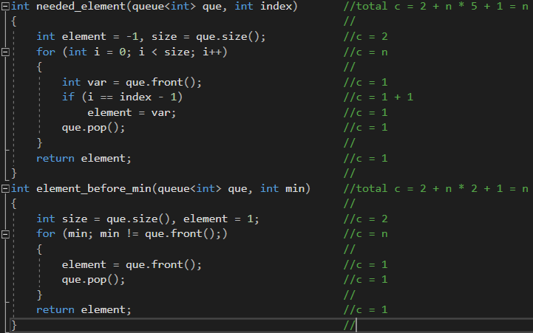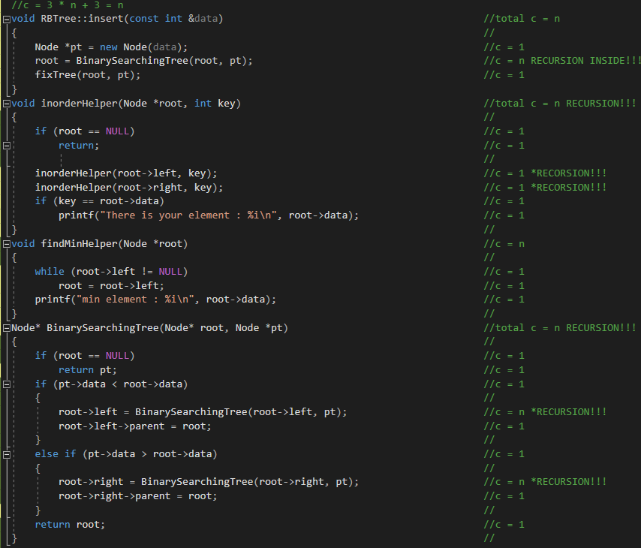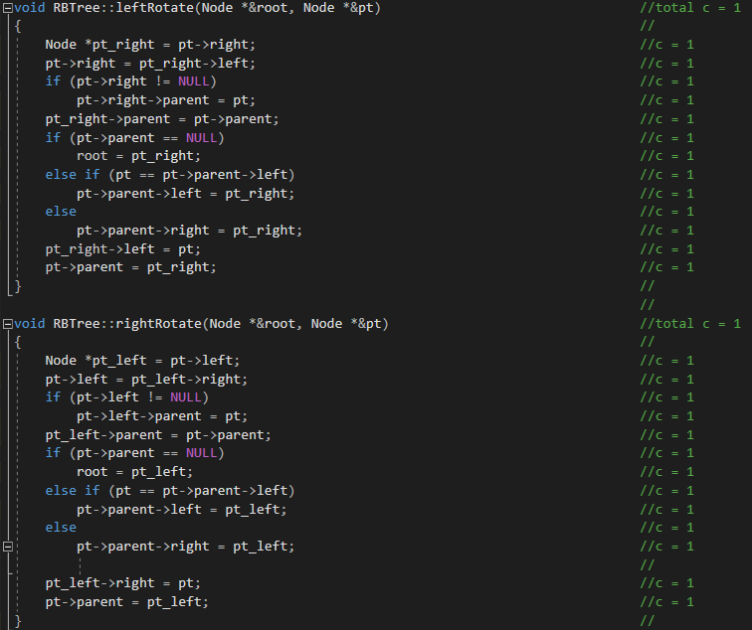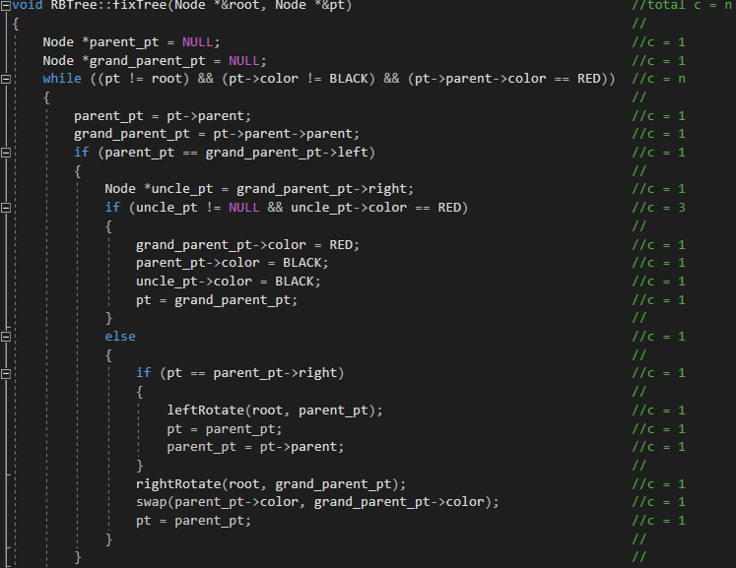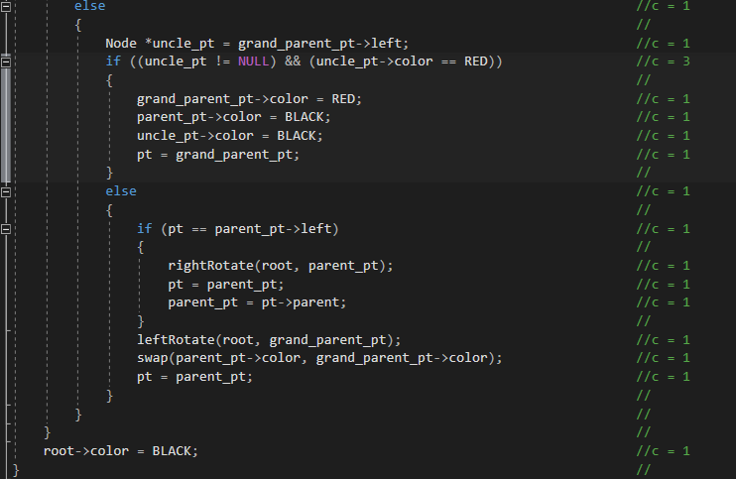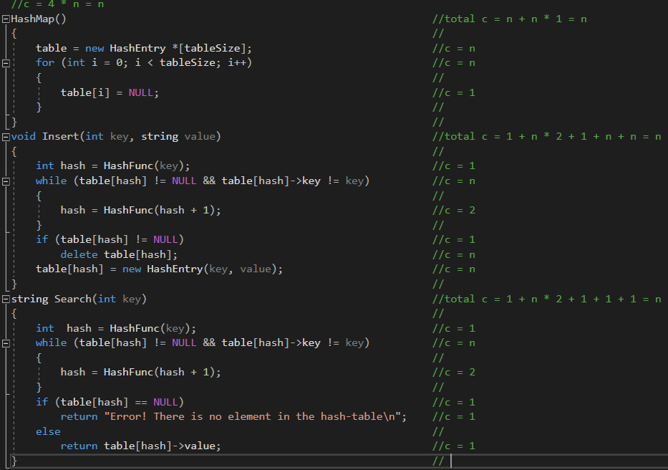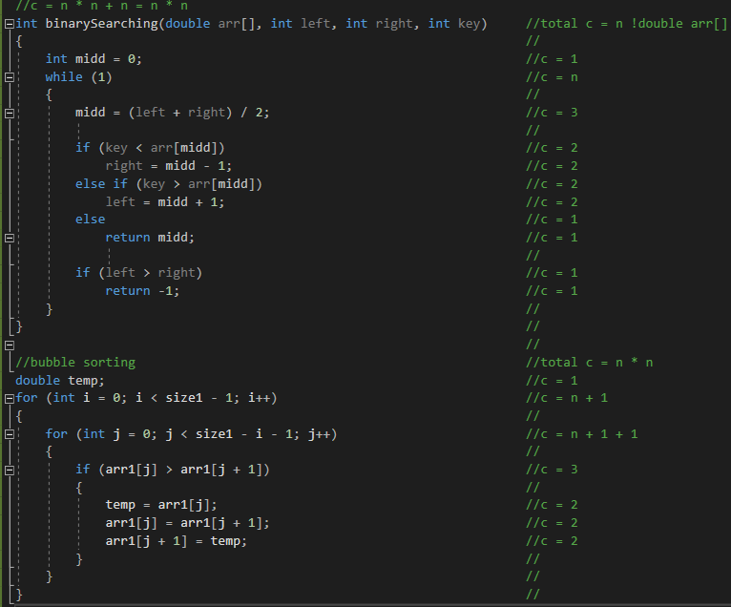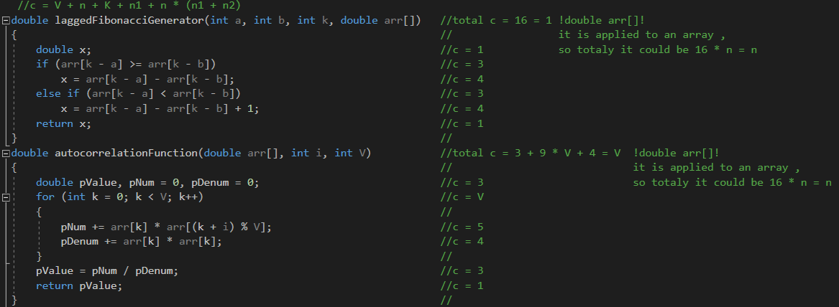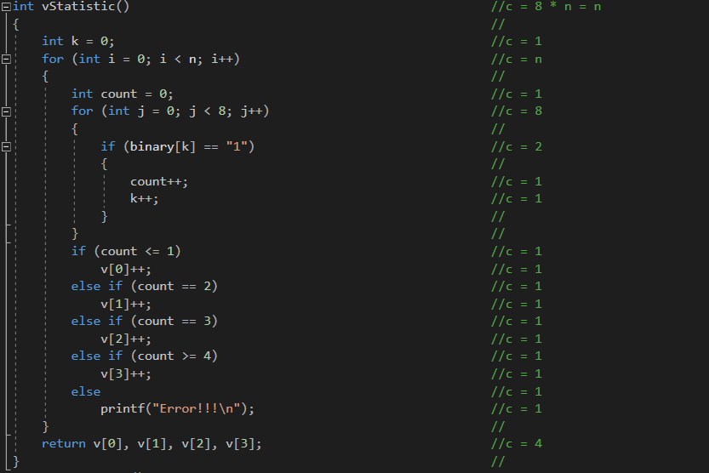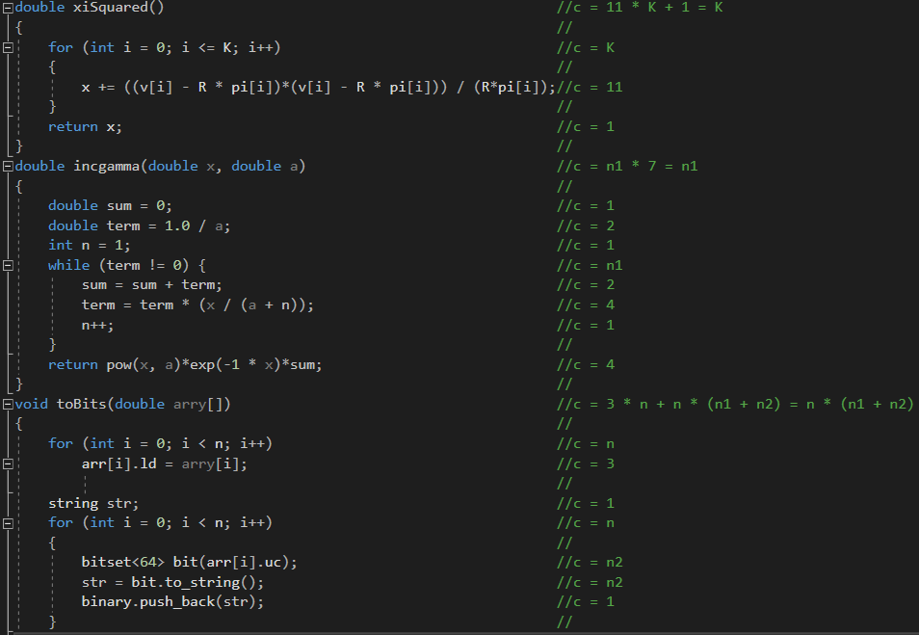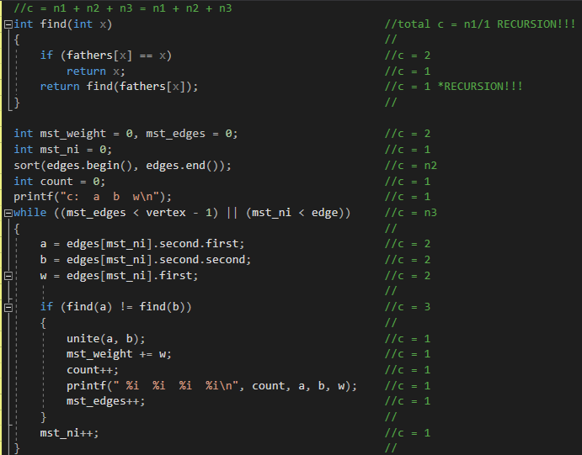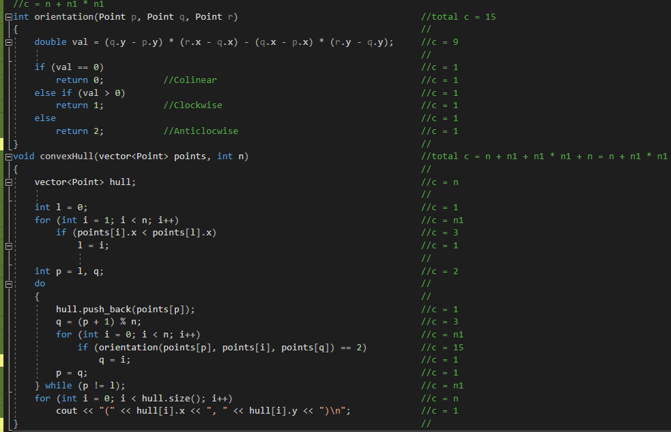

Conclusions: At that lab were received knowladges about how to identify complexity of algorithms using sign Θ. There were learned information about main features of calculations of complexity of an algorithm.